Stamp Album

Version 5.0.3

User Manual
- Author: Boris du Reau
- Development Period: 2003–2026
- Technologies: Python 3, PyQt6, SQLite / MS Access
- Copyright: Boris du Reau 2003–2026

Table of Contents
- Overview and Technical Specifications
- Installation and Prerequisites
- Getting Started and Quick Start
- Managing Pages and Formats
- Handling and Laying Out Stamps
- Creating and Editing Objects (Text and Images)
- Precision Tools: Rulers, Guides, and Alignment
- Visual Reorganization via Contact Sheet (Thumbnails)
- AlbumEasy Import
- Printing and PDF Export
- Configuration and Customization
- Managing the Image Library and Databases

1. Overview and Technical Specifications
Stamp Album Creator is a WYSIWYG tool for creating and laying out custom stamp albums. Originally developed in VBA in the early 2000s, the application has been entirely modernized in Python 3 and PyQt6.

Technical Specifications
- Operating System: Windows, macOS, Linux (with a Python 3.8+ environment).
- Recommended CPU / RAM: Intel Core i5 / AMD Ryzen 5, 8 GB RAM.
- Album File Format: Compressed .sta save file (XML/gzip structure).
- Supported Exports: High-resolution PDF (single page or full album).
- Supported Languages: French and English.

2. Installation and Prerequisites

Running from Python Source Code
If you are running the program from the source code, install the required dependencies: pip install PyQt6 openpyxl pyodbc.

Databases (SQLite vs MS Access)
- SQLite (Recommended): No additional component is required. The application uses sqlite3 and reads databases from the databases/ folder.
- Microsoft Access (.mdb/.accdb): If you use the Access engine, install Microsoft ODBC drivers (e.g., accessdatabaseengine_X64.exe /quiet).

But you can run as a normal application by just downloading it.

3. Getting Started and Quick Start

3.1 Starting the Application
Launch the application by double-clicking the executable or by running python main.py.
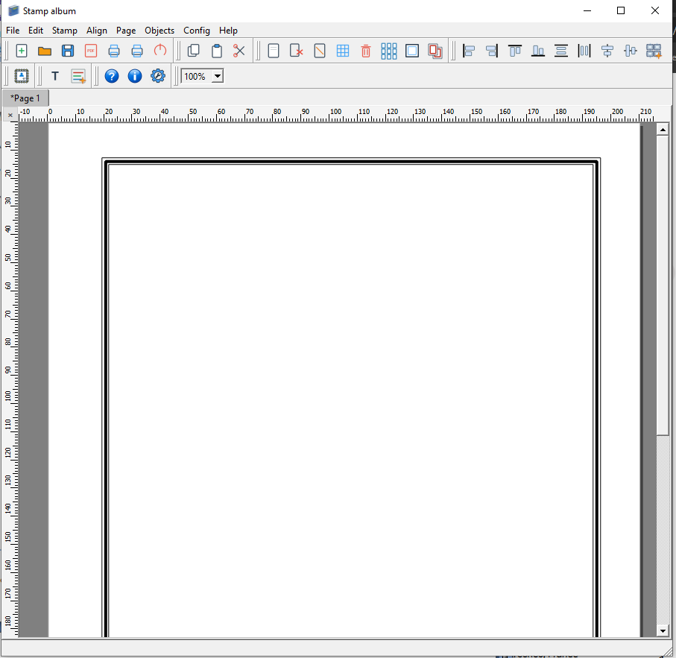*

3.2 Interface Overview
The main screen consists of:
- Menu Bar: File, Edit, Stamp, Align, Page, Objects, Config, Help.
- Interactive Toolbars: Quick access to creation, manipulation, and page layout.
- Zoom Selector: Allows adjusting the view scale from 25% to 200%.
- Central Tab Area: Displays album pages (Page 1, Page 2, etc.). A symbol in front of the name indicates unsaved changes.
- Millimeter Rulers: Located at the top and left of the workspace.

4. Managing Pages and Formats

4.1 Adding a Page
Click Page -> New Page... or the toolbar icon. A dialog box allows you to choose:
- Orientation: Portrait or Landscape.
- Border Style: Classic triple frame, simple, Greek, or lace.

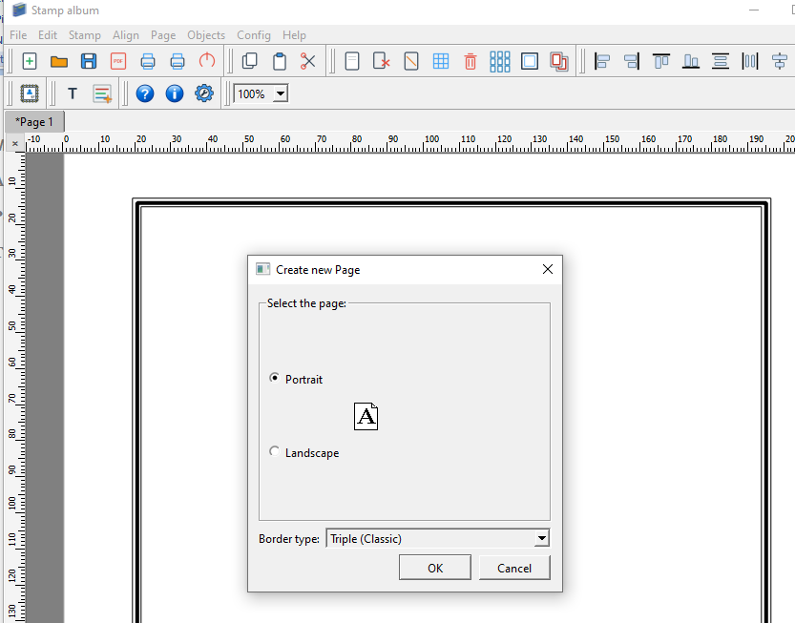

4.2 Paper Formats
The application natively supports A4 (210x297mm) and US Letter (215.9x279.4mm) formats, configurable in global options.

4.3 Modifying the Border Style
You can modify the border of the active page (Page -> Change Border Style...) or apply it to all pages in the album (Change Border of All Pages).

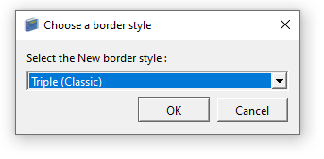

5. Handling and Laying Out Stamps

5.1 Adding a Stamp from the Catalog
- Go to Stamp -> New Stamp... (or the toolbar shortcut).
- Select Country, Category/Type, and Year.
- Choose the desired stamp from the drop-down list and click Create.
- The stamp is generated on the canvas as a graphic group containing the mount/frame, catalog number, face value, description, and photo.
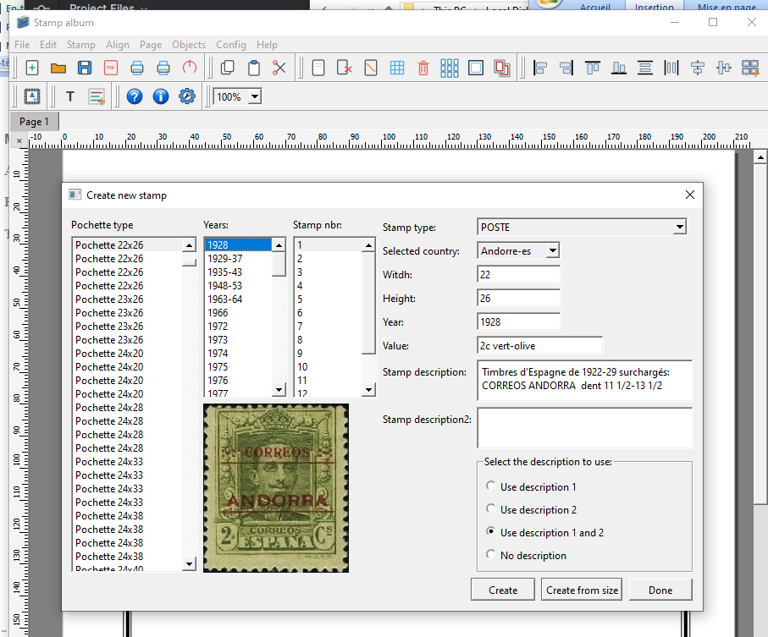

5.2 Editing an Existing Stamp
Double-click a stamp placed on the page to open the edit dialog:
- Title/description modification.
- Face value modification.
- Mount type adjustment (dimensions in mm).
- Replacement of the illustration image.

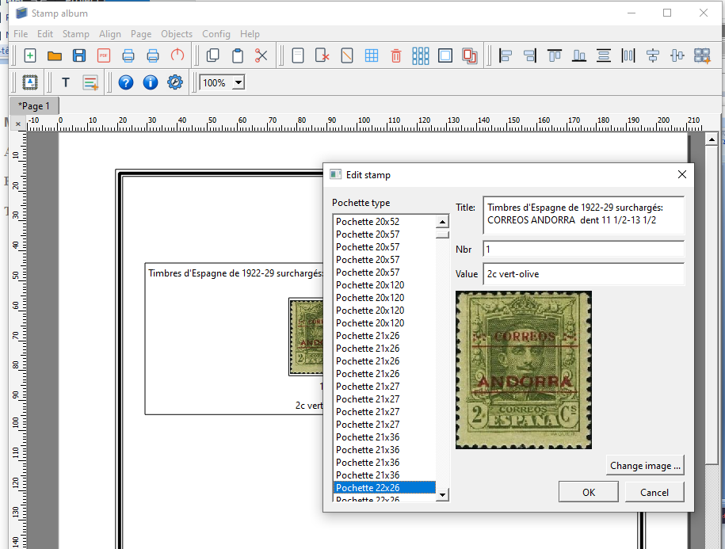

5.3 Automatic Rearrangement (Auto-arrange)
Click the Auto-arrange Stamps tool (Align -> Auto-arrange). The application automatically calculates available space and harmoniously realigns the stamps on the page into regular grids and rows.

6. Creating and Editing Objects (Text and Images)

6.1 Simple Text and Labels
Use Objects -> New Text... to add a text label. You can modify the font, size, style (bold, italic, underline), and centering.

6.2 Rich Text
Use Objects -> New Rich Text... to create complex information blocks featuring advanced HTML formatting (paragraph layouts, custom colors, lists).

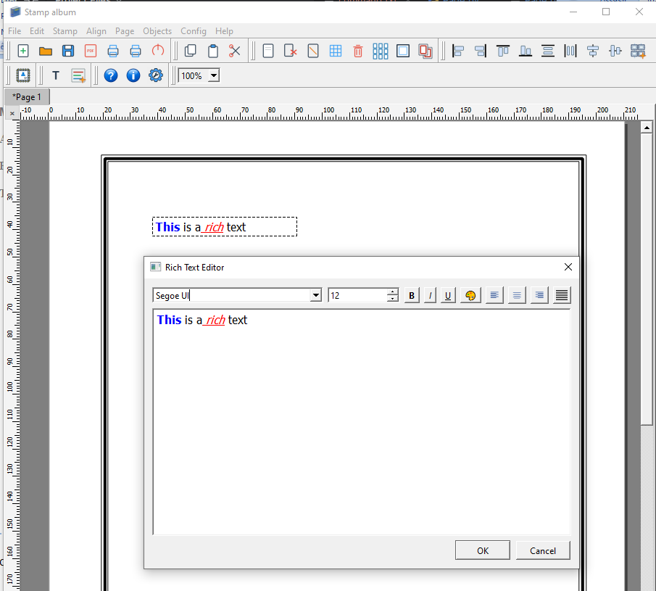

6.3 Inserting Standalone Images
Use Objects -> New Image... to import illustrations or additional visual assets (.png, .jpg). The inserted image includes interactive handles for direct mouse resizing.

7. Precision Tools: Rulers, Guides, and Alignment

7.1 Millimeter Rulers and Guide Lines
- Rulers: Rulers graduated in millimeters frame the view and adapt dynamically to the zoom level.
- Creating Guides: Left-click on the horizontal or vertical ruler to pull out a cyan guide line.
- Moving Guides: Drag the guide line across the page to align your stamps.
- Deleting Guides: Click the x button located in the top-left corner (at the intersection of both rulers) to clear all guides at once.
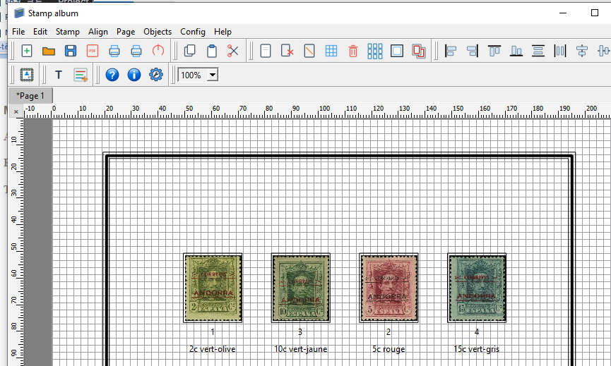

7.2 Alignment Toolbar
Select multiple objects using the Ctrl key or by drawing a selection box (Ctrl + A to select all), then apply transformations:
- Alignments: Left, Right, Top, Bottom.
- Centering: Center horizontally or vertically relative to the page frame.
- Distribution: Evenly distribute vertical or horizontal space among 3 or more objects.
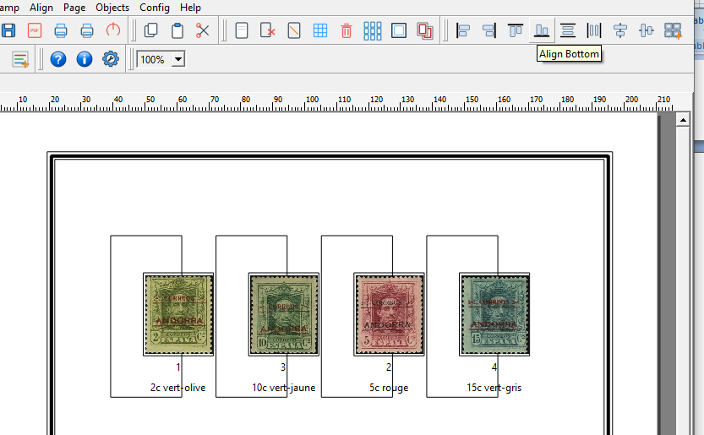

8. Visual Reorganization via Contact Sheet (Thumbnails)
To reorganize page order in your album:
- Click Page -> Contact Sheet... or the contact sheet icon.
- A window opens showing visual thumbnails of all pages.
- Drag and drop thumbnails to change page order.
- Confirm: the application automatically reorders the tabs and updates page numbers.

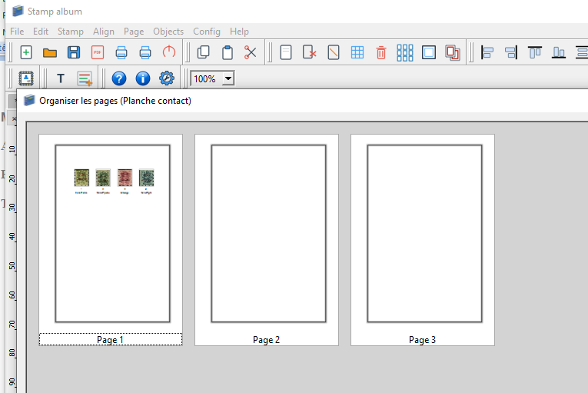

9. AlbumEasy Import (Experimental)
The application can import text album files created with AlbumEasy software (.txt):
- Go to File -> Import AlbumEasy...
- Choose whether to replace the current album or append the pages.
- The application interprets spacing, titles, frames, and stamp dimensions to recreate the layout in PyQt.

10. Printing and PDF Export

10.1 PDF Export of Current Page
Click File -> Print Page to PDF... to generate a .pdf file of the active page directly.

10.2 Print Preview and Full Album Export
- Preview: File -> Print Preview (Page / Album) opens the QPrintPreviewDialog module.
- Full Export: File -> Print All Pages... generates a high-resolution, multi-page PDF document ready for final printing.

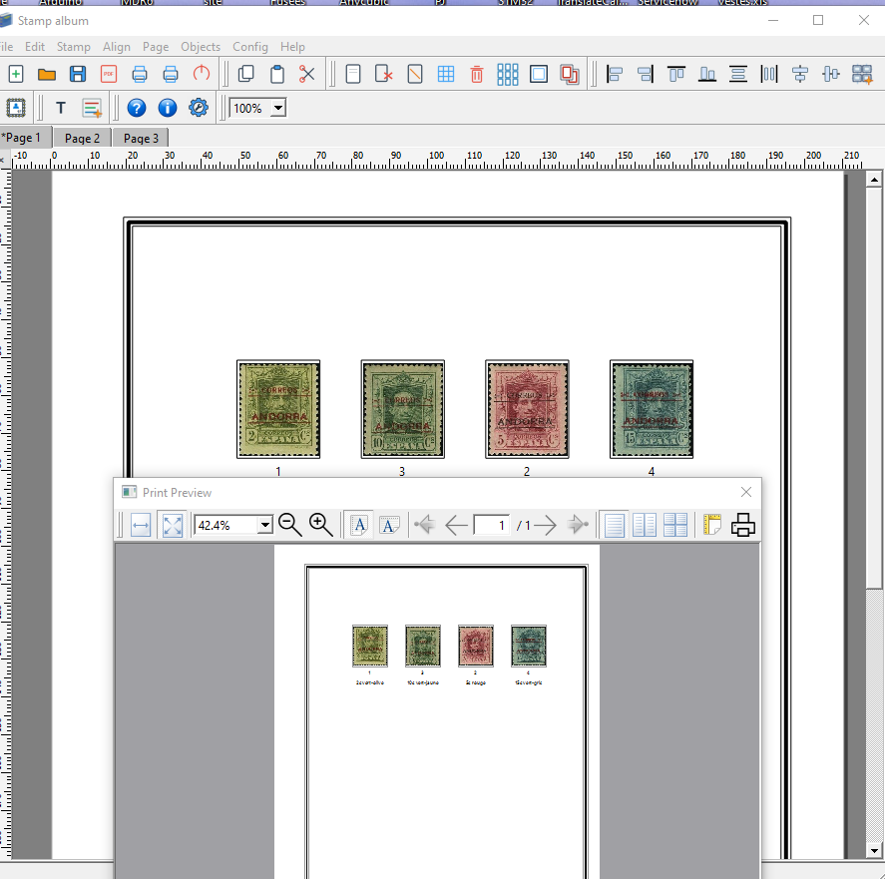11. Configuration and Customization
Open Config -> Application Configuration... to adjust default settings:
- Default Copyright: Automatic copyright text entry.
- Language: Interface language selection (French or English).
- Default Paper Format: A4 or US Letter.
- Default Border: Frame style applied by default when creating a page.
- Default Font: Selection among system fonts via QFontComboBox.
- Database Engine: SQLite or Access.

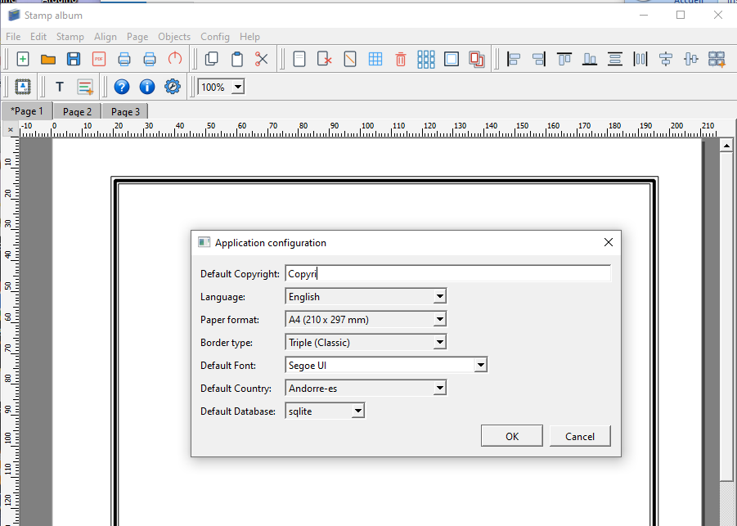

12. Managing the Image Library and Databases

12.1 Image File Organization
Stamp visuals are stored in .jpg or .png format inside the Images/ or photos/ directory. The application resolves the image filename using the getPhotoName function, which parses the catalog number and stamp type:
- Airmail (A): T01-030-XXX.jpg
- Souvenir Sheet / Miniature Sheet (BF): T01-080-XXX.jpg
- Official Stamp (S): T01-170-XXX.jpg
- Standard Postage: T01-000-XXX.jpg

12.2 Adding a New Country
To add a new country use the StampDatabase application:
- Create an SQLite file named .db in the databases/ folder.
- The primary table Stamp_List must contain the following schema: key, nbr, year, type, valuecolor, stampDescription, width, height, sequence, ascii_seq, sub_nbr.

